***ECoding Hen Sore***

***Document Version***:1.0

***Author Name***: Maheswari Selvam

***Application Information***

*App Name*: EHen_Web app

*Customer Name*: Ecoding Client

*Development Team*: Maheswari Selvam (Full stack Developer)

*Web URL*: <http://localhot:4200> (local host URL)

***About Documentation File:***

The purpose of this file is to provide overview, setup instructions and background information of the project.

***Tools and Hardware requirement declaration:***

***Software Requirements:***

* Windows OS
* Nodejs (for node module installation)
* Visual Studio 2022
* Microsoft SQL Server Management studio
* Front End Technology- Angular
* Back end Techology - .Net core

***Setup Instructions:***

***Angular installation setup:***

* Install Node/npm on your machine.
* Install Angular CLI ( npm install -g @angular/cli)
* Create an angular project ( ng new my-app )
* For running the application after development-ng serve(dev)/ ng build(Prod/QA)

Note: give this above command in the command prompt

***Visual Studio installation setup:***

Follow the instruction from the below URL for visual studio setup:

<https://learn.microsoft.com/en-us/visualstudio/install/install-visual-studio?view=vs-2022>

***SQL Server management studio setup:***

Follow the instruction from below URL for SQL server management studio setup:

<https://learn.microsoft.com/en-us/sql/ssms/download-sql-server-management-studio-ssms?view=sql-server-ver16>

Provide the code for frontend and backend technologies in git hub, provided the link below for the git hub repo

Front end:

<https://github.com/maheswari97/Ecoding_App/tree/main/EHen_APP_FE>

Back end: <https://github.com/maheswari97/Ecoding_App/tree/main/EHen_APP_BE/EHen_Web_App>

SQL Query:

<https://github.com/maheswari97/Ecoding_App/tree/main/SQL%20Query>

***Application overview:***

***Main Page:***

On the load of application, it will show the Below details

* Hiearchy Level
* Total Hen count in the Hierarchy
* Total Egg count in the Hierarchy
* Final price of the per Egg in that Hierarchy, final price is calculated as
  + Egg final price = egg base price + 1% hen commission.
  + The 1% hen commission can be calculated as 1% of the Sum of the price of all eggs that the hens laid from the lower hierarchy level on the given day. (Only 1 hierarchy level below).
* Available Hens id and their respective Egg count in that hierarchy
* There will be a dropdown for choosing the date ,base price of egg will differ based on the date, user can change the base price.
* There will be a buttons for Add new hens in hierarchy,add new hens in already existing hierarchy,edit existing hens and edit price index

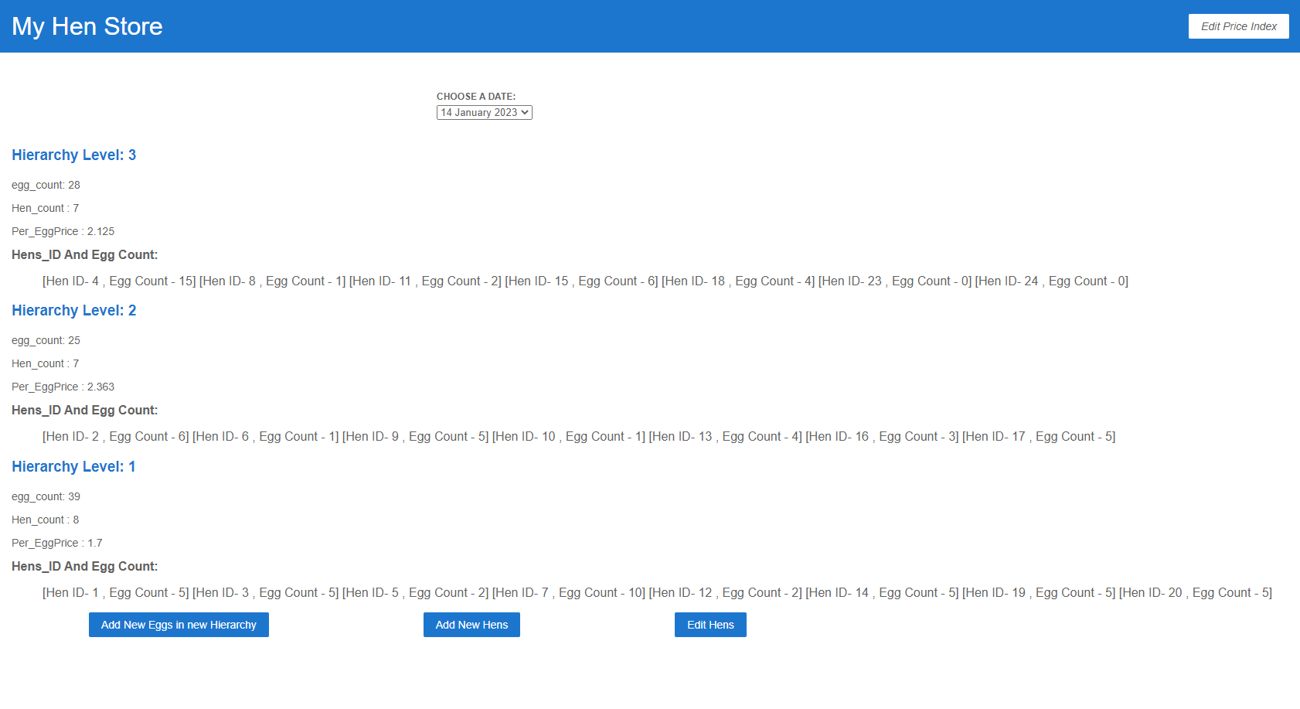

***Edit Price Index:***

* User can change the base price of an egg by clicking the button on the top right corner “Edit price index”
* It will redirect to the page that contains date and their respective base price of an egg
* By clicking edit for the respective date user want to change the price, it will redirect to the page that contains price and date in editable form
* In that form user can edit the price and update ,the same will be refelected in the price index page and the Per_EggPrice in the main page

**Click on Edit price index**

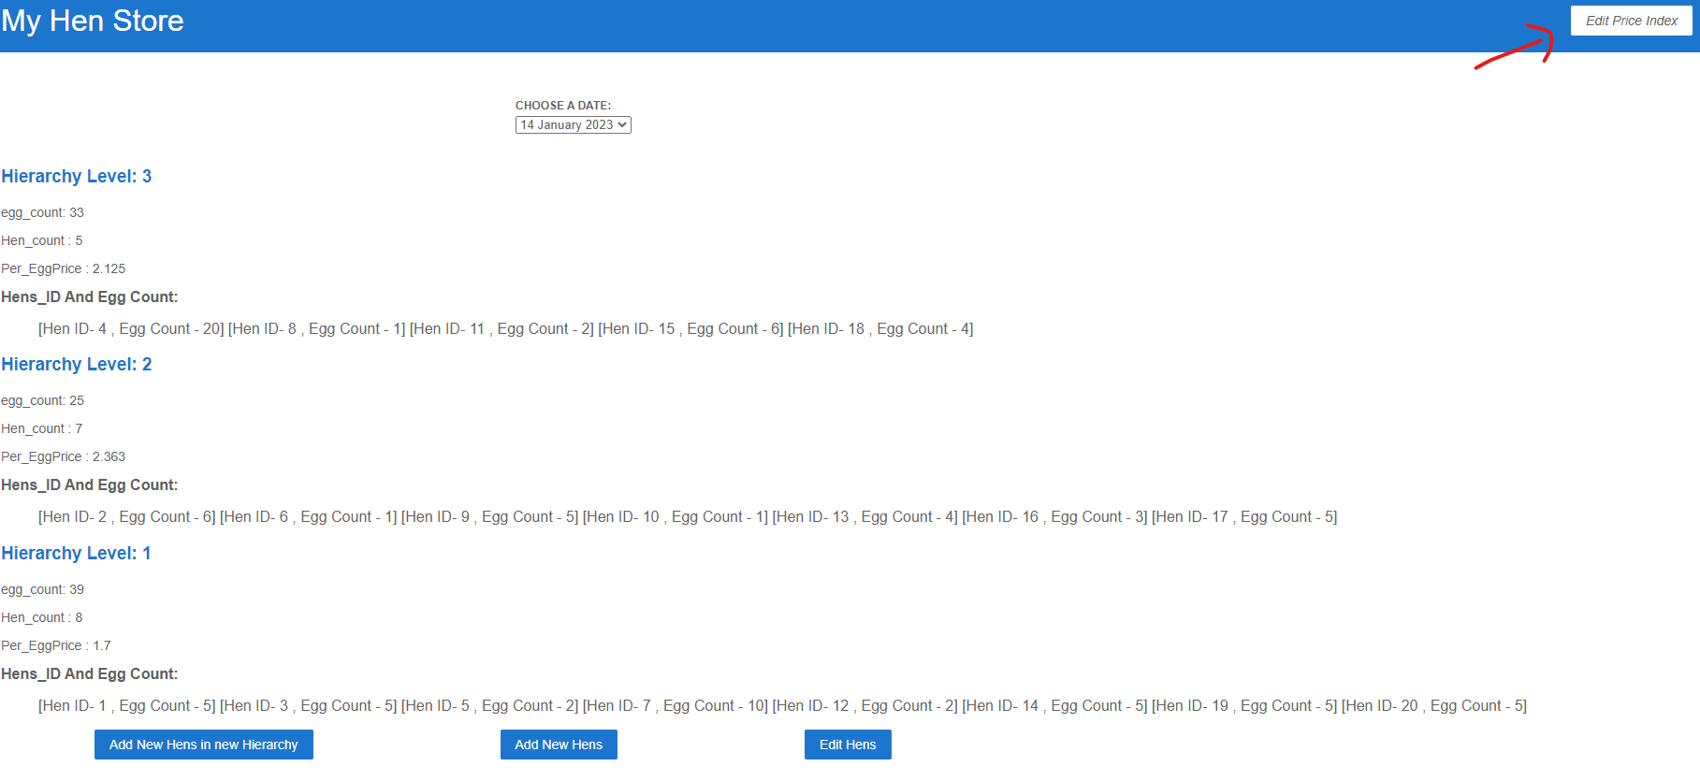

**Click on edit button for the respective date user wants to change the price**

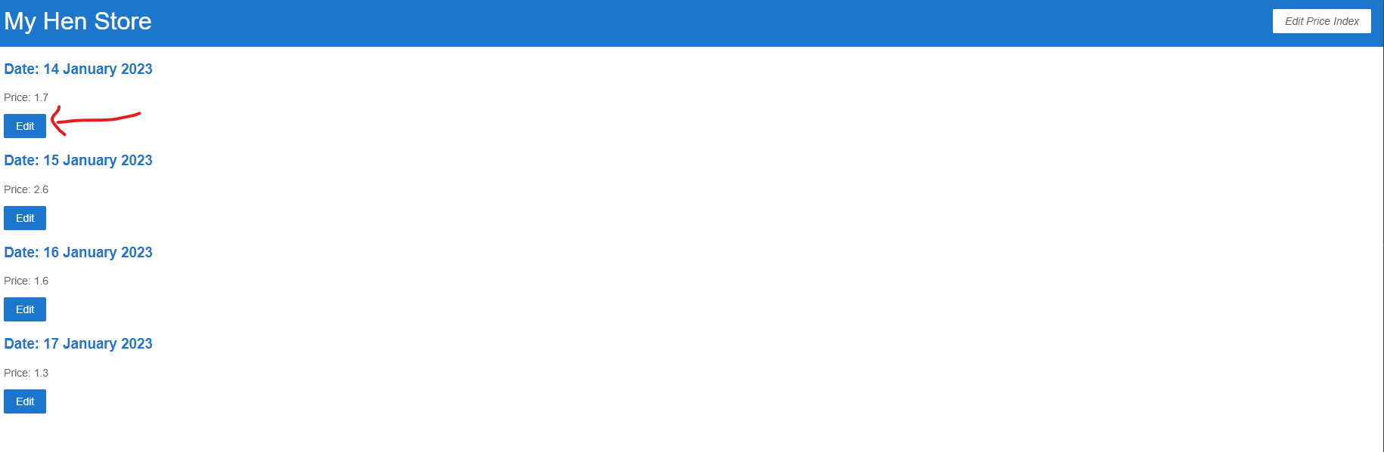

**Edit the price**

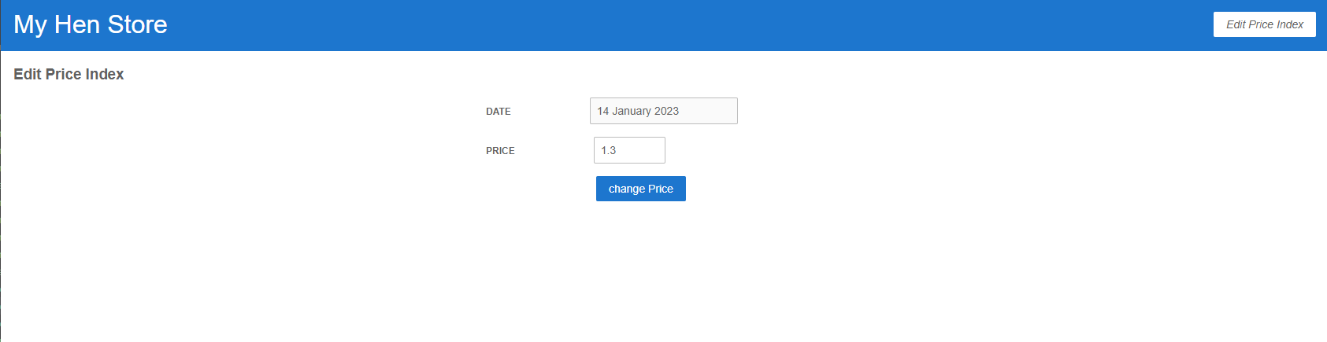

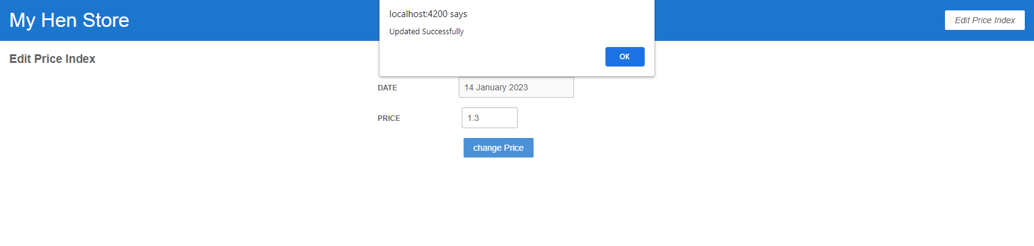

**Price will be update in the price index page**

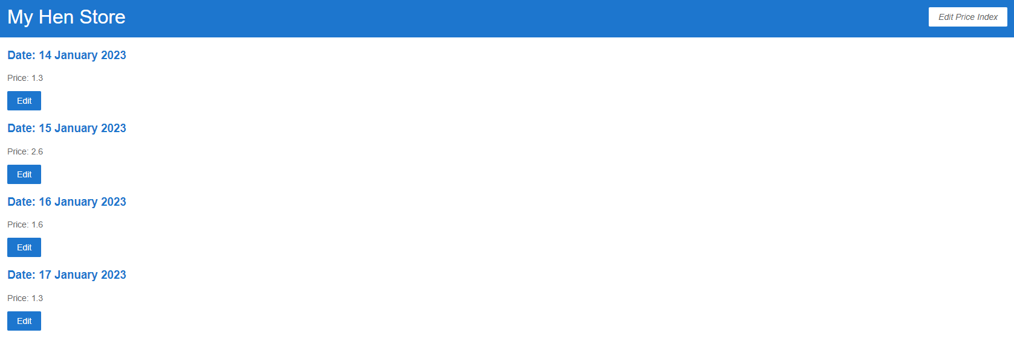

***Add New Hens in New Hierarchy:***

* New Hierarchy can be created above all previous hierarchy by clicking the bottom button “Add new Hens in New Hierarchy”
* After clicking the button it will be redirected to page where number of hens to the hierarchy can be added
* After the hens added same will reflected in the main page
* User cannot add eggs to the newly appear hen on the day they appear, it can be done on the following days

**Click on Add new hens in New Hierarchy:**

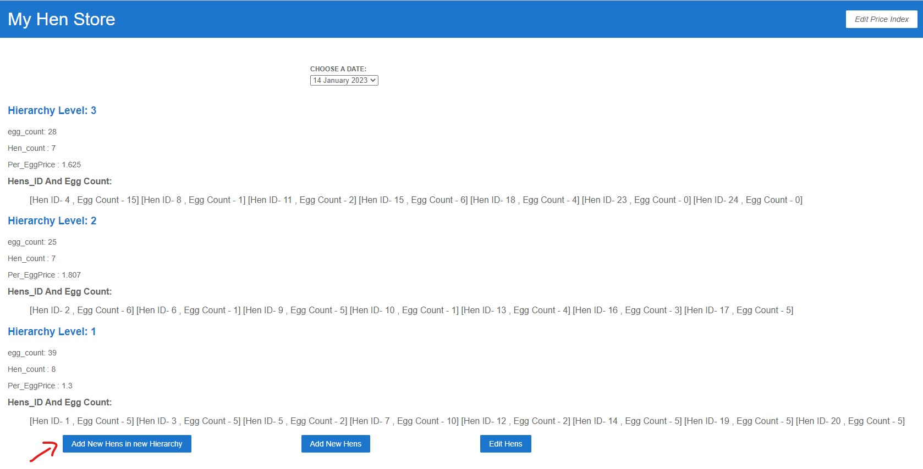

**Add the number of hens for the Hierarchy**

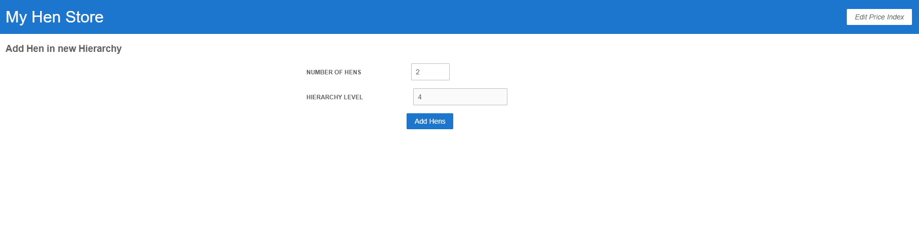

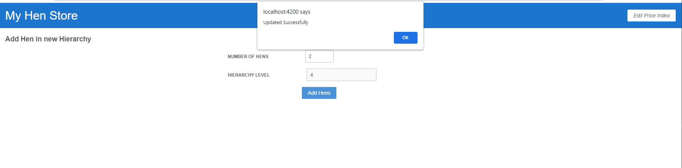

**New hens and New hierarchy will be reflected in the main page**

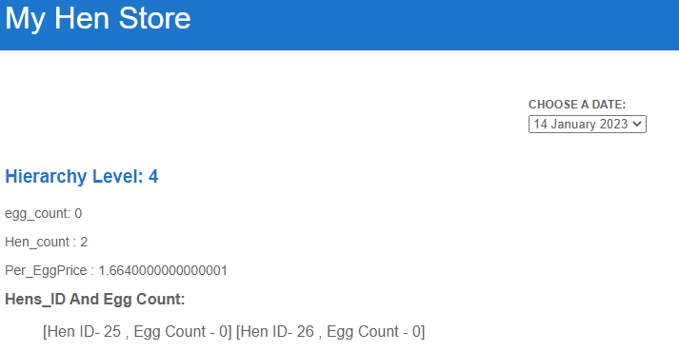

***Edit Hen***

* In Edit hen page, user can add the eggs for the respective hen with hen id and also can change the hen hierarchy
* User cannot add the eggs for the newly appear hens on the day they appear

**Click on Edit Hen button**

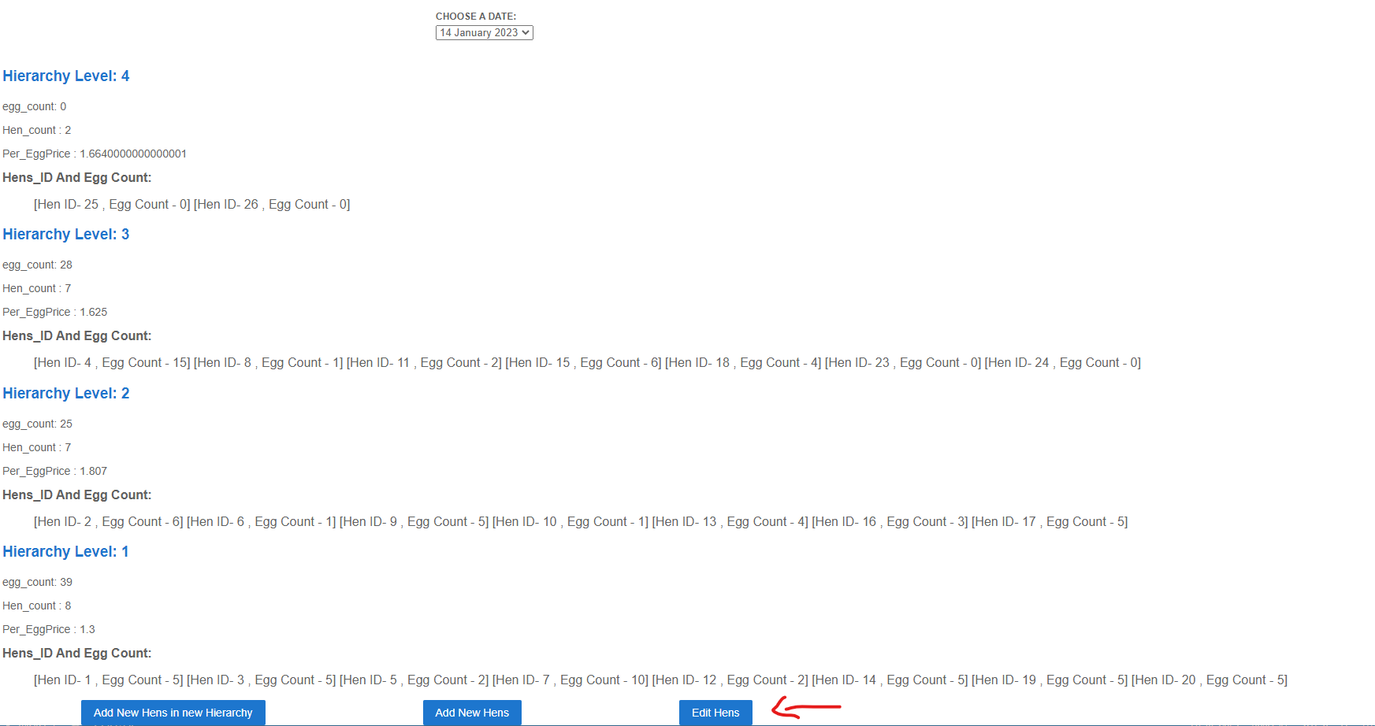

**Trying to add the egg to newly appear hen on the day they appear but application won’t allow**

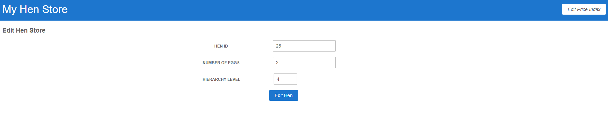

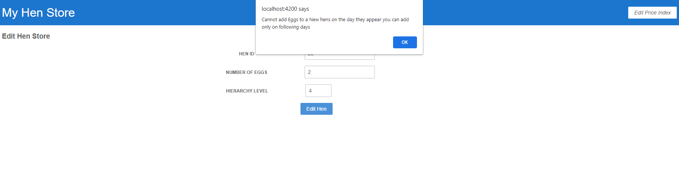

**Trying to add eggs to already existing hen(hen id -4) egg count-20, same will be reflected in the main page**

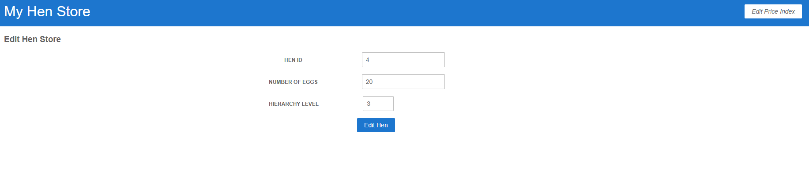

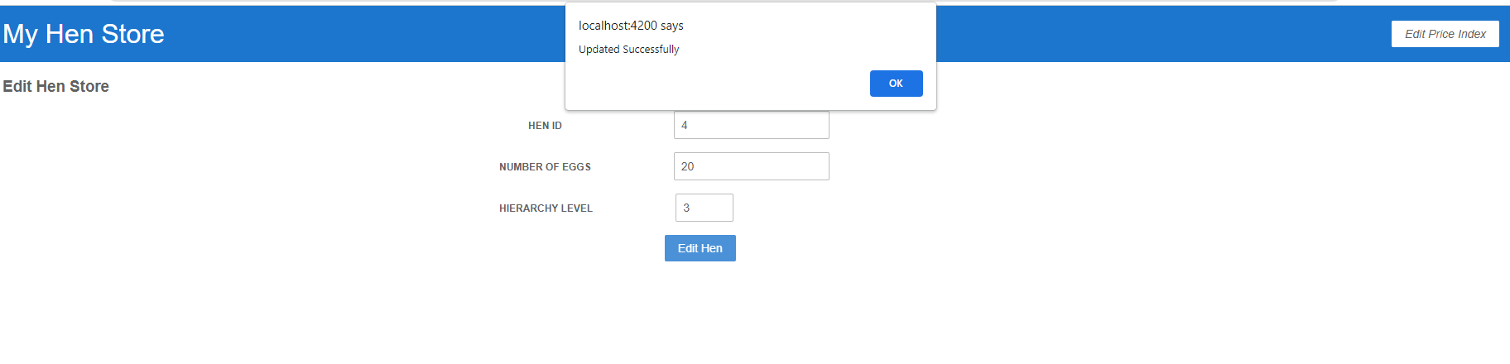

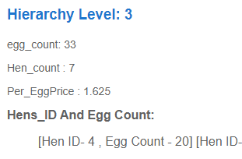

***Add Hen in already existing hierarchy:***

* User can add new hens to the already existing hierarchy
* By clicking add hen in the main page it will be redirected to the page where we can add number of new hens and the Hierarchy level
* After that same will be reflected in the main page

**Click on the “Add Hen” button**

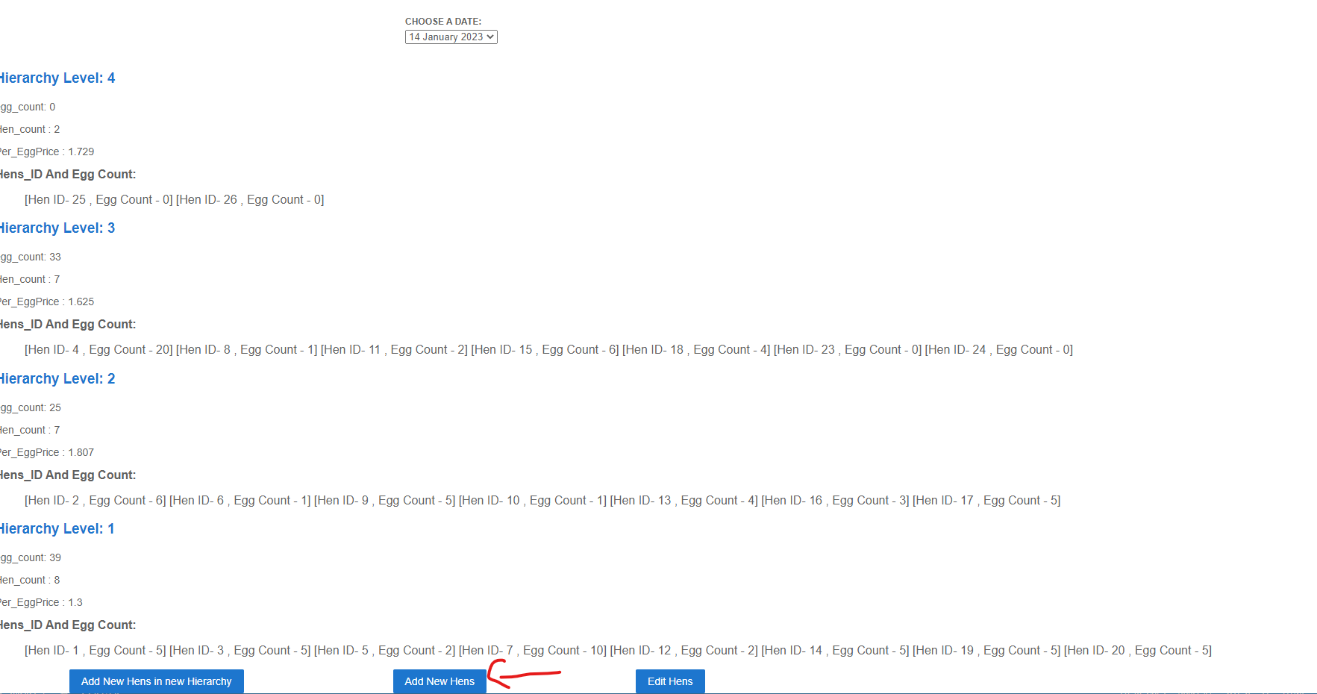

**Add the number of hens and hierarchy level (Hen number-2. Hierarchy level-4)**

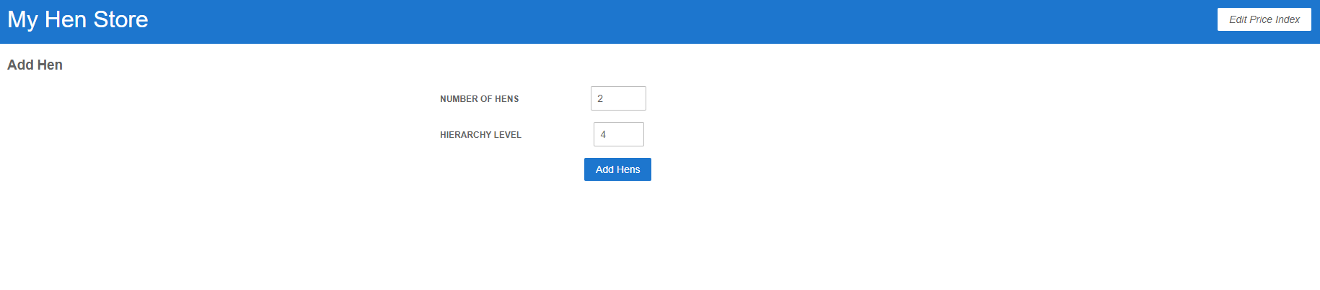

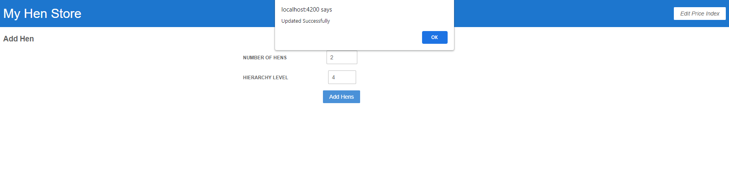

**Hens will be updated in that hierarchy**

